

Travis Vanos

Group 3

# GISC9216 – Digital Image Processing

GISC9216-D1



Mrs. Janet Finlay

Professor – GISC9216 January 29, 2016  
Niagara College *GISC9216-D1*  
135 Taylor Road  
Niagara-on-the-lake, ON  
L0S 1J0

Dear Mrs. Janet Finlay   
 **RE: Submission: GISC216-D1**

Please accept this letter as our formal submission of Assignment one: *GISC9216-D1-Introduction to Supervised Classification* for Travis Vanos. The works were completed with Erdas, for both unsupervised and supervised classification techniques. The purpose of this assignment is to successfully gain the required knowledge for bringing the concepts and methodologies learned in the Digital Image Processing course to compare the different classification methods. The requirements have been met along with the provided image subsets for study. The following procedures to be covered include, but are not limited to:

* Preform a supervised and unsupervised classification for the Landsat image subset
* Create “Training Areas” and Signature Classes to be used for supervised classification
* Compare and contrast the three different distance algorithms and determine best suited method

Following the assignment procedures, please find the required material attached. Should you have any questions regarding the enclosed documents, please contact Travis Vanos at your convenience at [travis.vanos@gmail.com](mailto:travis.vanos@gmail.com). We eagerly await your comments and suggestions.  
  
Sincerely,

Travis Vanos   
 GIS/GM Candidate, Niagara College  
 T. V.

Enclosures: VanosTGISC9216D1.docx

# Abstract

For the entire lifespan of areal imagery, since its first uses in war times, has been to distinguish and classify Areas of Interest (AOI) on the earth’s surface. With modern day computers it is up to GIS professionals to classify pixels in a set of raster image. With the aid of software the analysis of the areas takes place to attempt to properly classify types of terrain and features. There are two types of classifications used in this report: supervised and unsupervised classification. The objective of this report is to outline both methods and outline the effectiveness of each. The methodology is then presented to describe the process in which to perform the two classification methods were produced. Finally, the two methods are scrutinized for the effectiveness of classifying features in the Orilla area. The subsequent figures and maps are included.

Table of Contents

[Abstract i](#_Toc441830709)

[1. Introduction 1](#_Toc441830710)

[1.1 Image Creation 2](#_Toc441830711)

[1.2 Types of Classifications 2](#_Toc441830712)

[2 Summary of Unsupervised and Supervised Classification 4](#_Toc441830713)

[2.1 Minimum, Maximum and Mahalanobis Algorithms 4](#_Toc441830714)

[2.1 Minimum Supervised Classification vs. Unsupervised 6](#_Toc441830715)

[2.2 Conclusion 8](#_Toc441830716)

[Bibliography 9](#_Toc441830717)

List of Figures

[Figure 1 Study Area for Classification (512 x 512 pixel) image subset (Landsat, 1999) 1](#_Toc441830700)

[Figure 2 15 levels of Classification for desired features 2](#_Toc441830701)

[Figure 3 Example of Class Identification 3](#_Toc441830702)

[*Figure 4 (6) Classes of Histogram and Band 1 analysis* 5](#_Toc441830703)

[Figure 5 Distance Algorithms Output 5](#_Toc441830704)

[Figure 6 (15) Class Unsupervised Method 6](#_Toc441830705)

[Figure 7 (10) Class Unsupervised Method 7](#_Toc441830706)

[Figure 8 Stressed Earth Unsupervised vs. Supervised 8](#_Toc441830707)

# 1. Introduction

The objective of this report is to outline both methods and outline the effectiveness of both unsupervised and supervised classification of digital images. The task is completed by choosing Areas of Interest (AOI) and creating “Training Areas” for the two types of classification. The Orilla area in Ontario was chosen for its diversity of classifiable features and presence near water as seen in Figure 1.

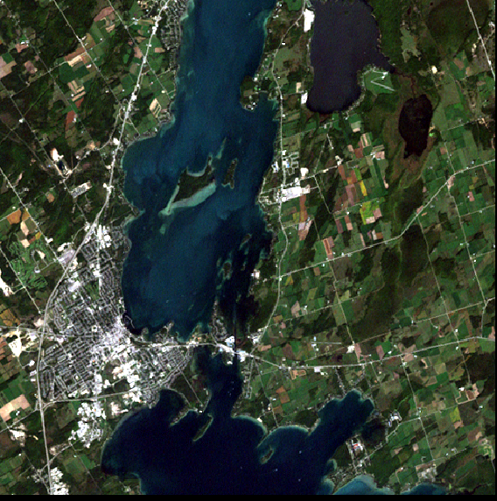

Figure 1 Study Area for Classification (512 x 512 pixel) image subset (Landsat, 1999)

## 1.1 Image Creation

A 512 x 512 pixel are of the Landsat imagery was chosen for a study area that would provide opportunity to classify all types of required areas for both supervised and unsupervised methods. The required area would have a plethora of water, agriculture, vegetation, barren earth, etc. the different types of classifications can be seen as an example in Figure 2.

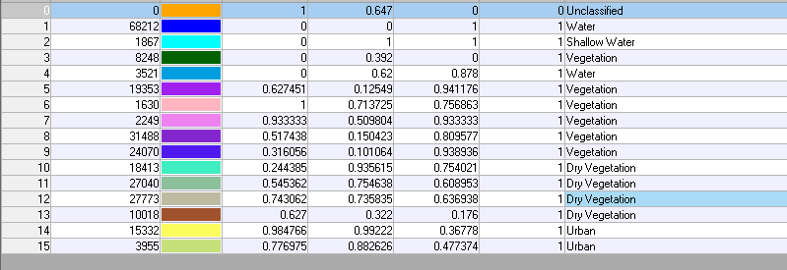

Figure 2 15 levels of Classification for desired features

## 1.2 Types of Classifications

With the desired study area obtained, both methods of classifications, supervised and unsupervised, are used to attempt identify desired features. Figure 3 provides an example of pixel identifiers to have a special class to provide a visual identification between drastically different land features (ex. Water, agriculture, rock).

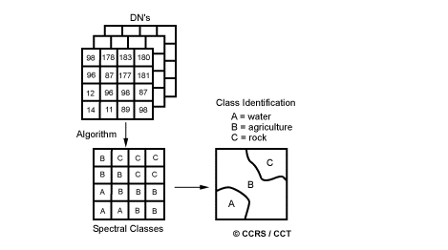

Figure 3 Example of Class Identification

**Unsupervised classification** invokes the grouping of features with like pixels signatures. The training site or range of pixels are not chosen by hand but rather algorithms that processes all pixels in an image subset and aggregates them into a number of classes based on image values. “The user can specify which algorism the software will use and the desired number of output classes but otherwise does not aid in the classification process. However, the user must have knowledge of the area being classified when the groupings of pixels with common characteristics produced by the computer have to be related to actual features on the ground (such as wetlands, developed areas, coniferous forests, etc.).” (Articles.extension.org)

**Supervised classification** is based on the idea that a user can select sample pixels, or “Training Areas” in an image that are representative of specific classes that can be used to represent all other pixels in the given image subset. Training sites (also known as testing sets or input classes) are selected based on the knowledge of the user. Each of these classifications is effective a grouping of like features, the classes are saved into a signature. “The user also designates the number of classes that the image is classified into. Many analysts use a combination of supervised and unsupervised classification processes to develop final output analysis and classified maps.” (Articles.extension.org)

# 2 Summary of Unsupervised and Supervised Classification

## 2.1 Minimum, Maximum and Mahalanobis Algorithms

Within the study area (6) “Training Areas” Have been created for the desired areas of interest and the difference for classifications can be seen shown in Figure 4. The histogram will display the pixel’s frequency (y-axis) as well as the value (x-axis). The different class can then be observed by band and how the supervised classification can determine the Areas of Interest but analysing these pixel values.

|  |  |
| --- | --- |
| H:\GISC9216 - DIP\Assignments\Assignment #1 - Classification\pics\Water_Band1.PNG | H:\GISC9216 - DIP\Assignments\Assignment #1 - Classification\pics\forest_band1.PNG |
| H:\GISC9216 - DIP\Assignments\Assignment #1 - Classification\pics\fertile_field_Band1.PNG | H:\GISC9216 - DIP\Assignments\Assignment #1 - Classification\pics\dry_field_band1.PNG |
| H:\GISC9216 - DIP\Assignments\Assignment #1 - Classification\pics\Shallow_Shoreline_Band1.PNG | H:\GISC9216 - DIP\Assignments\Assignment #1 - Classification\pics\Urban_Band_1.PNG |

*Figure 4 (6) Classes of Histogram and Band 1 analysis*

A signature file (.sig) can then be saved for the “Training Areas” used for the supervised classification. After the signature file has been saved the output can then be viewed with one of three different distance algorithms for classification. This can be seen for the three algorithms, **Minimum Distance, Maximum Distance** and **Mahalanobis**. Figure 5 shows the contrast in each algorithm.

|  |  |  |
| --- | --- | --- |
| **Minimum** | **Maximum** | **Mahalanobis** |
| H:\GISC9216 - DIP\Assignments\Assignment #1 - Classification\pics\min.PNG | H:\GISC9216 - DIP\Assignments\Assignment #1 - Classification\pics\max.PNG | H:\GISC9216 - DIP\Assignments\Assignment #1 - Classification\pics\mahalanobis.PNG |

Figure 5 Distance Algorithms Output

## 2.1 Minimum Supervised Classification vs. Unsupervised

The minimum supervised classification yielded the best results for the supervised classifications for this image subset. The supervised minimum classification was very efficient at defining the different water levels and well as urban and plant matter. However, in all supervised classification methods it was difficult to differentiate between the urban areas and stressed agriculture. This was better identified in the unsupervised classification for these areas which were able to pick establish a larger divide between the two classes’ signatures. In both Figure 6 and figure 7 below, the 10 class and 15 class unsupervised classifications we are able to see the stressed agriculture separate from the larger urban area of Orillia.   
  
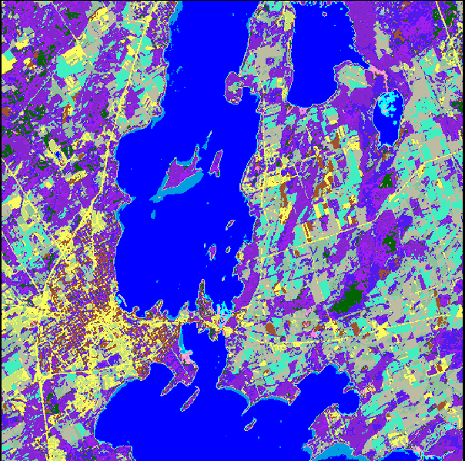

Figure 6 (15) Class Unsupervised Method

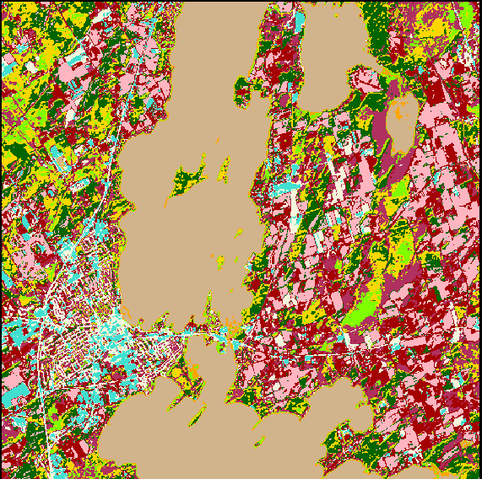

Figure 7 (10) Class Unsupervised Method

In the minimum supervised classification, chosen for this assignment, was based on aesthetics and the ability to differentiate the different water levels and vegetation types. This, however, was done more efficiently in the unsupervised classification as seen in Figure 8. The unsupervised classification can be seen to minimize human error as the software can automatically select the different pixel reflectance values to group them together. The unsupervised classification with the more classes of features has the higher precision for classification.

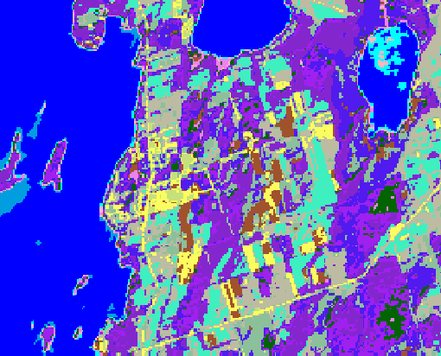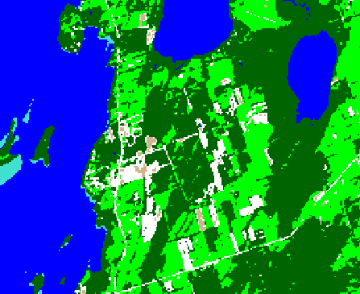

Figure 8 Stressed Earth Unsupervised vs. Supervised

## 2.2 Conclusion

In closing, one can clearly see the differences in what features each classification method was able to determine. There are clear advantages and disadvantages that must be weighed before choosing a method. If time is a factor rather than extreme precision, unclassified with (15) classes would be the chosen method as it successfully determined the differences in the shallow water, stressed agriculture and most of the urban areas. A professional, unfamiliar with the area, would see the greatest time vs. precision ratio achieved with this unsupervised classification method.

# Bibliography

Articles.extension.org,. "What's The Difference Between A Supervised And Unsupervised Image Classification? - Extension". N.p., 2016. Web. 29 Jan. 2016.

Nrcan.gc.ca,. "Image Classification And Analysis | Natural Resources Canada". N.p., 2013. Web. 29 Jan. 2016.